Draft Class Strength and NBA Tanking Incentives
Nico L, Leo K, Colin C

Abstract
This project studies whether stronger National Basketball Association (NBA) draft classes are associated with tanking among teams with weak playoff outlooks, being those which are outside of playoff contention. Using NBA team and player game logs from 2010 through 2026 and CraftedNBA draft prospect ratings, we build a team-season dataset that compares each team’s performance before March 1 to its performance after March 1. As the project developed, we moved away from a simple binary definition of tanking and instead used a standardized tanking index, which measures how many fewer games a team won late in the season than expected from its pre-March record. We also changed the draft-strength measure from a broad top-35 average to the average rating of the top four prospects, because lottery incentives are most directly tied to access to the top of the draft. The main win-loss result is suggestive rather than conclusive: likely lottery teams with larger position-adjusted draft incentives tend to have larger late-season win shortfalls, but the evidence is limited by the fact that draft quality varies mostly by season and tanking intent is not directly observable. When developing a proxy for tanking characterized by reduced play from starters, our exploratory analysis finds a stronger relationship between top four draft strength and reduced late-season minutes for continuing core players, which points to roster management as a useful follow-up tanking signal.

I. Introduction
Our research question is: Are stronger NBA draft classes associated with more late-season underperformance among teams with weak playoff outlooks, especially when a team’s lottery position gives it more to gain from losing?
The original project proposal focused on whether stronger draft classes create stronger incentives for NBA teams to tank. As we looked more closely at the data, the question became more specific in three ways. First, we stopped treating tanking as something we could directly observe. Instead, we measure late-season underperformance among teams with weak postseason outlooks. Second, we changed the draft-strength measure to focus on the top four prospects rather than the average quality of a much larger prospect group, since the NBA lottery primarily gives teams access to the very top of the draft. Third, we made the incentive team-specific by combining top-four draft strength with each team’s estimated lottery position entering March. This matters because the same draft class does not create the same incentive for every team.

II. Background
This question is about incentives, but our data cannot directly observe intent. We therefore measure tanking signals, not confirmed tanking. A tanking signal is a team-season where a team had a weak postseason outlook entering March and then performed worse than expected late in the regular season.
The NBA draft lottery determines which non-playoff teams receive the first picks in the draft. Worse teams generally receive better lottery odds, which creates the basic incentive problem: a team that is unlikely to make the playoffs may benefit from losing more late-season games if doing so improves its draft position. The NBA changed its lottery odds beginning with the 2019 draft, flattening the odds at the top. Under the current format, the three worst teams each have a 14.0% chance at the first pick, while other lottery teams receive lower odds. The modern lottery determines the first four picks, which is why our preferred draft-strength measure focuses on the average quality of the top four prospects rather than the full draft class.
Prior research has studied tanking as a response to draft lottery incentives. Taylor and Trogdon (2002) and Price et al. (2010) examine whether NBA teams lose more often when the reward for losing is larger. Our project builds on that idea by adding a second source of incentive: the quality of the incoming draft class. Instead of treating every draft as equally valuable, we ask whether likely lottery teams appear to underperform more when the player pool at the top of the draft is stronger and when moving down in the standings would increase their chance of landing a top-four pick.

III. Data Gathering
We use two main source families. First, NBA game logs come from the hoopR package. The team game logs provide the game date, team, opponent, score, and win/loss result. We also use player game logs from hoopR to build an exploratory team-fit measure based on pre-March production by position group. Second, draft class quality comes from CraftedNBA draft class rankings and prospect-level data from CraftedNBA’s draft pages. The main draft-quality variable is top4_avg_rating, the average CraftedNBA rating of the top four prospects in that draft class. We also keep the top-35 average rating, prospect positions, number of elite prospects, number of above-average prospects, and rating of the top prospect as alternate draft-strength information.
The final dataset contains 510 team-seasons from 2010 through 2026. Each row is one team in one season. To make the main incentive variable vary by team, we combine draft strength with each team’s estimated March 1 lottery position and probability of landing a top-four pick. This does not fully eliminate the season-level limitation, but it better represents the fact that the same draft class creates different incentives for the worst team, the fifth-worst team, and a fringe lottery team.
We split each season on March 1. The next steps were filtering to regular-season games, aggregating team records before and after March 1, ranking teams by pre-March league record to estimate lottery position, merging in draft class ratings, and constructing the late-season underperformance measures described below.
The lottery-position adjustment uses published NBA lottery weights. Before the 2019 reform, the lottery drew the first three picks; after the reform, it draws the first four picks. We use those weights to calculate each seed’s probability of finishing in the top four, then calculate how much that probability would rise from moving one lottery slot worse.
Key constructed variables:
- pre_win_pct and late_win_pct are each team’s winning percentage before March 1 and on or after March 1.
$$\text{Pre-March win pct}=\frac{W_{\text{pre}}}{G_{\text{pre}}}, \text{Late win pct}=\frac{W_{\text{late}}}{G_{\text{late}}}$$
- pre_win_pct is used as a baseline team-strength control because a team that was already very weak before March should not be evaluated the same way as a team that was close to .500.
- games_back_cutline measures how far a team was from the postseason/play-in cutoff entering March. For seasons before the play-in era, the cutoff is the 8th seed. For seasons beginning in 2021, the cutoff is the 10th seed. We use this to help identify teams with weak playoff outlooks.
$$\text{Games back}=max\left(0,\frac{\left(W_{\text{cutline}}-W_{\text{team}}\right)+\left(L_{\text{team}}-L_{\text{cutline}}\right)}{2}\right)$$
- likely_lottery_candidate is our sample filter for teams that plausibly had an incentive to prioritize draft position over late-season wins.
$$\text{Likely lottery candidate}=\left\{\begin{matrix}1, & \text{outside cutoff and }\left(\text{games back}≥3\text{ or pre-March win pct}<0.400\right) \\ 0, & \text{otherwise}\end{matrix}\right.$$
- This is not an outcome variable; it defines the group of teams used in the formal models.
- top4_avg_rating is the average CraftedNBA rating of the top four prospects in a draft class.
$$\text{Top-four average rating}=\frac{r_{1}+r_{2}+r_{3}+r_{4}}{4}$$
- Higher values mean a stronger top of the draft. This variable is the same for every team in the same season, so raw top-four draft-strength models are interpreted as draft-class-level evidence.
- marginal_lottery_incentive is our team-specific draft incentive. First, we calculate how much a team’s probability of landing a top-four pick would increase if it moved one lottery slot worse. Then we multiply that probability gain by top4_avg_rating.
$$\text{Marginal lottery incentive}=\text{Top-four average rating}×\text{Marginal top-four-pick probability gain}$$
- For example, if moving from the fifth-worst to fourth-worst record increases a team’s top-four-pick probability, that gain is more valuable in a year with a stronger top four. Teams with no added top-four-pick probability from moving one slot worse, such as the worst team, receive a marginal incentive of 0.
- tanking_index is the main win-loss outcome. It compares a team’s actual March-onward wins to the number of late-season wins expected from its pre-March winning percentage.
$$E\left(W_{\text{late}}\right)=G_{\text{late}}×p_{\text{pre}}$$
$$\text{Tanking index}=\frac{E\left(W_{\text{late}}\right)-W_{\text{late}}}{\sqrt{G_{\text{late}}p_{\text{pre}}\left(1-p_{\text{pre}}\right)}}$$
- Here, $p_{\text{pre}}$ is the team’s pre-March winning percentage and $E\left(W_{\text{late}}\right)$ is the expected number of March-onward wins under that pre-March win rate. The denominator is the expected standard deviation of late-season wins under a binomial model; dividing by it puts teams with different numbers of late-season games on the same scale. The code uses a small lower bound on the denominator for numerical stability.
- Positive values mean the team won fewer late-season games than expected. Values near 0 mean it performed about as expected. Negative values mean it overperformed late in the season.
- team_fit_score is an exploratory team-specific measure of whether a team’s weakest position groups match the strongest position groups in that year’s draft. We group players and prospects into three position groups: guards, wings, and bigs. For each team-position group before March 1, we calculate a simple production rate:
$$\text{Value per 36}=36×\frac{\text{points}+\text{rebounds}+\text{assists}+\text{steals}+\text{blocks}-\text{turnovers}}{\text{minutes}}$$
- Within each season and position group, we standardize value per 36 across teams. A team gets a positive need score only where it is below average:
$${\text{Position need}}_{g}=max\left(0,-z\left({\text{Value per 36}}_{g}\right)\right)$$
- We then measure draft supply using the top 35 CraftedNBA prospects. Each prospect’s draft value is:
$${\text{Draft value}}_{j}=max\left({\text{rating}}_{j}-50,0\right)$$
- For each position group, draft value is converted into a share of all top-35 draft value:
Draft value shareg=j∈g​Draft valuejj​Draft valuej
- The final score is:
Team fit score=g∈{Guard, Wing, Big}​Position needg×Draft value shareg
- Higher values mean a team was weak at positions where that draft had more high-rated prospects. This is a rough proxy for roster fit, not a team-specific draft board.
- core_usage_drop_rate is an exploratory roster-management outcome. For each team-season, we identify the team’s top three pre-March core players by starts, breaking ties by minutes. We keep only core players who appeared for the same team after March 1, so traded players are not counted as “benched.” We then calculate their combined minutes per team game before and after March:
$$\text{Core usage drop rate}=\frac{\text{Pre-March core MPG}-\text{Late core MPG}}{\text{Pre-March core MPG}}$$
- MPG means minutes per game. Positive values mean the team’s main continuing pre-March players were used less after March 1. This does not prove healthy starters were benched; injuries, rest, development minutes, and coaching decisions can also reduce minutes.
- season_2012, season_2020, and season_2021 are separate controls for disrupted seasons. We use separate indicators because the 2012 lockout season, 2020 bubble season, and 2021 shortened COVID-era season may have affected late-season performance in different ways. We do not treat season as a continuous linear predictor in the formal models.

IV. Data Analysis
This section tells the main descriptive story in the data before moving to regression models. The key questions are whether likely lottery teams look different from other teams, whether late-season underperformance is rare or common, and whether stronger top-end draft classes line up with larger late-season win shortfalls.
Table 1. Summary statistics by lottery era and team group.
Era | Group | N | Pre win pct | Late win pct | Tanking index
Post-reform (2019-2026) | Likely lottery candidates | 73 | 0.325 | 0.323 | 0.039
 | Other teams | 167 | 0.577 | 0.574 | 0.028
Pre-reform (2010-2018) | Likely lottery candidates | 102 | 0.340 | 0.338 | -0.022
 | Other teams | 168 | 0.597 | 0.598 | 0.039
Table 1 shows that the average pre-to-late change is small in percentage-point terms in both eras, which suggests that most weak teams do not collapse late in the year. The final regression relies on the full tanking index, which measures degree of late-season underperformance instead of forcing teams into a yes/no collapse category.
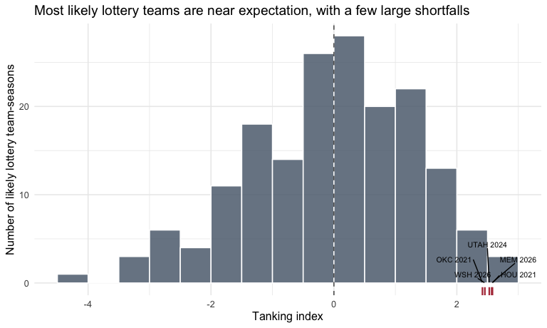
Figure 1. Distribution of the tanking index among likely lottery candidates. Positive values mean a team won fewer March-onward games than expected from its pre-March record, while negative values mean it won more than expected. Labels identify the largest positive outliers.
Figure 1 shows that the response variable is centered near 0, but there is a noticeable right tail. In plain terms, most likely lottery teams did about what their pre-March records predicted, while a smaller set had unusually large late-season win shortfalls. Utah is a useful recent example. The 2024 Jazz have a tanking index of 2.53, which ranks 3rd among likely lottery candidates in the dataset, and Utah remains positive in both 2025 (1.84) and 2026 (1.21). The public league context points in the same direction: the New York Post reported in 2026 that the NBA fined the Jazz $500,000 and the Pacers $100,000 for player-participation violations connected to sitting or removing key players while the teams were near the bottom of the standings.
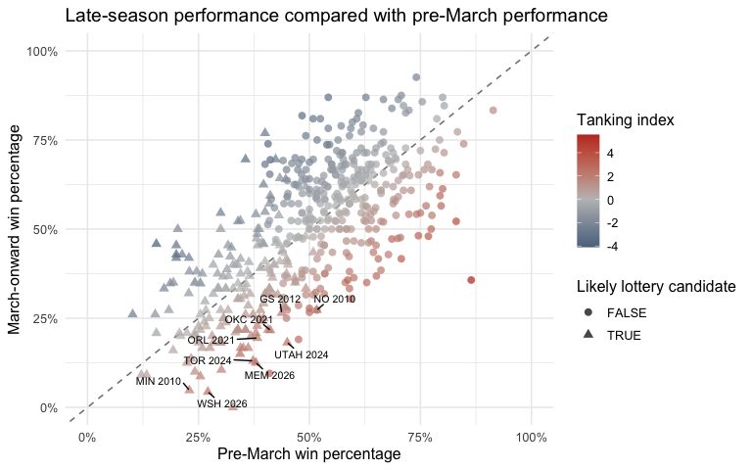
Figure 2. Late-season performance compared with pre-March performance. Each point is one team-season from 2010 through 2026. The dashed line shows equal pre-March and March-onward win percentages. Triangles are likely lottery candidates. Color shows the tanking index, where higher values mean larger late-season win shortfalls. Labels identify the largest tanking-index seasons among likely lottery candidates.
Figure 2 shows that most teams cluster near the diagonal, meaning their late-season winning percentage was similar to their pre-March winning percentage. The darker red points are teams with larger positive tanking-index values: they won substantially fewer late-season games than expected from their earlier record. This is why the regression below uses the full tanking_index rather than a binary collapse label.
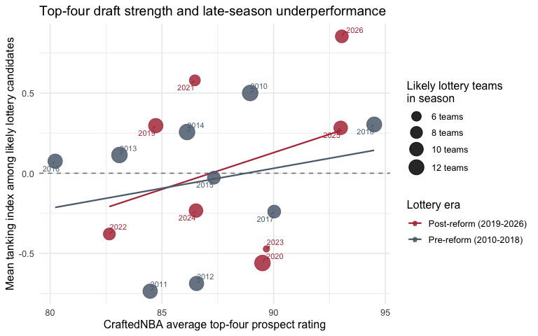
Figure 3. Top-four draft strength and average late-season underperformance among likely lottery candidates. Each point is one NBA season. The x-axis is the CraftedNBA average rating of the top four prospects, the y-axis is the mean tanking index among likely lottery candidates, and point size is the number of likely lottery team-seasons in that year. Fitted lines are descriptive and are shown separately for the pre-reform and post-reform lottery eras.
Figure 3 provides exploratory context rather than the final model specification. The pre-reform and post-reform fitted lines are shown descriptively, but the final regression below pools all years together. The graph still shows why the conclusion should be cautious: there are only 17 season-level draft class observations, and 2021 remains unusual because it was affected by COVID-era scheduling and roster disruptions.
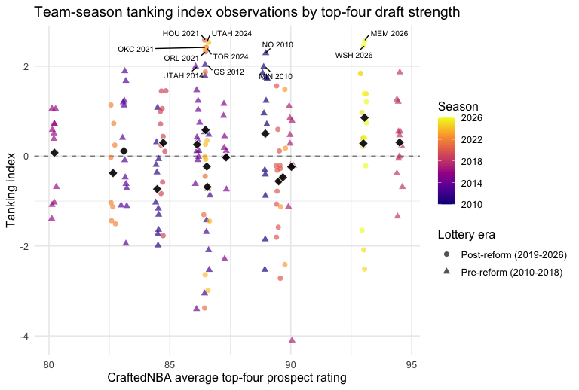
Figure 4. Team-season observations for top-four draft strength and late-season underperformance among likely lottery candidates. Each point is one likely lottery team-season. The x-axis is jittered slightly because every team in the same season has the same top-four draft rating. Color shows season, shape shows lottery era, and the black diamonds show the season-level averages from Figure 3.
Figure 4 makes the observational unit clearer. Each point is a team-season, while the black diamonds are the season averages used in Figure 3. The vertical stacks show why the season-level summary can hide variation: teams in the same draft year share the same top-four draft rating, but their tanking-index values differ widely.
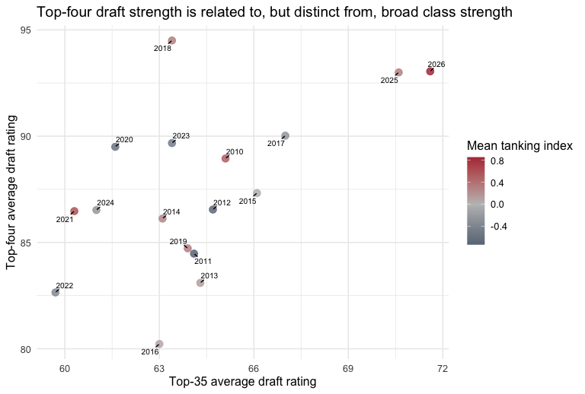
Figure 5. Comparing broad and top-four draft-strength measures. Each point is one NBA draft class from 2010 through 2026. The x-axis is the top-35 average rating, the y-axis is the top-four average rating, and color shows the mean tanking index among likely lottery candidates in that season.
Figure 5 shows why the top-four measure is useful. It is related to the broader top-35 class rating, but it is not identical. The top-four measure focuses on the players lottery teams are most realistically trying to access, so it is more directly tied to the incentive mechanism than the average quality of the full top 35.
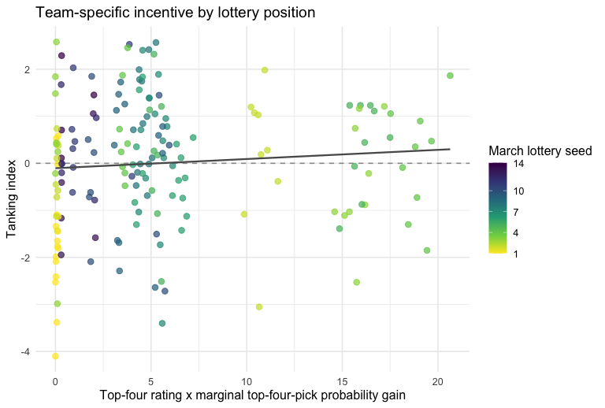
Figure 6. Position-adjusted draft incentive and tanking index among likely lottery candidates. Each point is one team-season. The x-axis combines top-four draft class rating with the marginal gain in top-four-pick probability from moving one lottery slot worse. Zero-incentive points are nudged slightly to the right only to reveal overlapping observations; the fitted line and regression models use the exact, unnudged incentive values.
Figure 6 directly addresses the concern that a draft class has the same top four rating for every team in the same year. Observations at zero are meaningful: they are teams that would not gain additional top-four-pick probability by moving one slot worse, such as the worst team. The relationship is noisier than the season-average figures, which is expected: the outcome is still affected by injuries, trades, resting, and random late-season variation.

V. Formal Analysis
The formal analysis uses likely lottery candidates only, because those are the teams with the clearest incentive to lose late-season games. To avoid making the results depend on an arbitrary 10 percentage point cutoff, the outcome is the full tanking_index. This is a standardized late-season win deficit with positive values meaning a team won fewer March-onward games than expected from its pre-March record, while negative values mean it overperformed late.
All formal regression models in this section use team-season outcomes, not one observation per season. In other words, a team like Houston in 2021 and Orlando in 2021 are separate rows because they had different pre-March records, lottery positions, marginal lottery incentives, team-fit scores, core-player usage patterns, and late-season outcomes. However, not every explanatory variable varies at the team-season level. Raw top4_avg_rating is the same for every team in the same draft year, so models using only raw draft strength should be interpreted as evidence about season-level draft-class strength, not as 172 fully independent draft-strength observations. To address this, we emphasize team-specific variables such as marginal_lottery_incentive and team_fit_score when the research question is about team-level incentives, and we report season-clustered inference for the core-player usage checks that use raw top-four draft rating.
The main win-loss model’s key coefficient is the standardized position-adjusted draft incentive. It asks whether teams with larger marginal lottery rewards in stronger top-four draft classes have larger tanking signals after controlling for pre-March team strength and separate indicators for the disrupted 2012, 2020, and 2021 seasons. We also include follow-up checks for whether the relationship changed after the 2019 lottery reform, whether a team’s roster fit with the draft class adds explanatory power, and whether stronger top-four draft classes are associated with late-season reductions in core-player minutes.

Analysis 1: Pre/Post Reform Interaction
Table 2. Exploratory pre/post lottery reform interaction model with standard errors clustered by season.
Outcome | Term | Estimate | Clustered std. error | Season-clustered p-value
Tanking index | Top-four draft rating | 0.077 | 0.069 | 0.285
 | Post-2019 reform | 0.101 | 0.162 | 0.542
 | Top-four draft rating x post-2019 | 0.207 | 0.139 | 0.154
Table 2 tests whether the relationship between top-four draft strength and the tanking index changed after the 2019 lottery reform. The main terms to look at are the top-four draft rating coefficient and its interaction with the post-2019 reform indicator. The top-four draft rating coefficient shows the pre-reform relationship between draft strength and late-season underperformance. The interaction term shows whether that relationship became stronger or weaker after the reform. Because the interaction p-value is 0.15, the change is not statistically significant. We therefore treat this as an exploratory check, not evidence that the lottery reform clearly changed the draft-strength/tanking relationship.

Analysis 2: Position-Adjusted Team-Season Regression
Our next model looks at all seasons together and focuses on the team-specific draft incentive. This variable combines how strong the top of the draft class was with how much a team could improve its top-four pick odds by losing more games. That matters because a strong draft class does not create the same incentive for every lottery team.
We use pre_win_pct to control for how good or bad a team already was before March. We do not include games_back_cutline in the regression because it is closely related to pre_win_pct, but it still helps us decide which teams count as likely lottery candidates. Our preferred draft-strength measure is top4_avg_rating because the lottery is mostly about access to the very top of the draft, not the entire class.
The outcome is tanking_index, which measures how many fewer games a team won after March 1 than expected based on its earlier record. We use the full index instead of a yes/no tanking label because it captures the size and direction of late-season underperformance. A higher tanking_index means a stronger tanking signal.
Table 3. Main pooled regression model using position-adjusted draft incentives among likely lottery candidates.
Model | Term | Estimate | Std. error | p-value
Tanking index | Position-adjusted draft incentive | 0.157 | 0.099 | 0.115
 | Pre-March win pct | 4.852 | 1.135 | 0.000
 | 2012 season | -0.741 | 0.403 | 0.068
 | 2020 season | -0.610 | 0.374 | 0.105
 | 2021 season | 0.567 | 0.500 | 0.258
The tanking-index model has a positive position-adjusted incentive coefficient of 0.157, with a p-value of 0.12. Since the incentive variable is standardized, this means that a likely lottery team with a one-standard-deviation larger marginal top-four draft incentive is expected to have a tanking index 0.157 units higher, holding pre-March win percentage and disrupted-season controls fixed. Because positive tanking-index values mean more late-season wins below expectation, the result points in the direction predicted by the tanking-incentive story, though the evidence remains suggestive rather than conclusive.
Because 2021 is visibly unusual in the exploratory graphs, we also refit the same all-years models after removing only the 2021 season. This is a sensitivity check, not a replacement for the main model:
Table 4. Sensitivity check comparing position-adjusted models with models excluding 2021.
Outcome | Sample | Term | Estimate | p-value
Tanking index | All years | Position-adjusted draft incentive | 0.157 | 0.115
 | Excluding 2021 | Position-adjusted draft incentive | 0.145 | 0.140
Excluding 2021 does not change the direction of the result. The position-adjusted incentive coefficient remains positive, changing from 0.157 to 0.145, while the p-value changes from 0.12 to 0.14. This suggests 2021 affects the estimate, but the main pattern is not only driven by that season.

Analysis 3: Team-Fit Heterogeneity Check
Based on peer review feedback, we add an exploratory team_fit_score to account for whether a draft class fit a team’s needs. This variable measures whether a team was weak at the same positions where that draft class had the most value. We group both NBA players and draft prospects into guards, wings, and bigs, then compare each team’s pre-March production at those positions with the position mix of the top 35 prospects. Higher team_fit_score values mean the draft class fit that team’s roster needs more closely. This measure is only weakly correlated with top-four draft rating among likely lottery candidates (0.009), so it captures something different from overall draft strength.
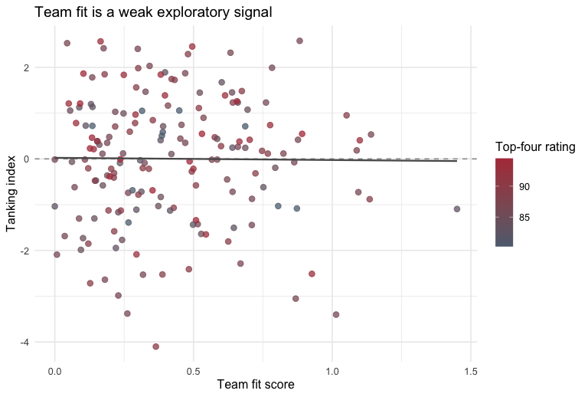
Figure 7. Team fit and tanking index among likely lottery candidates. Each point is one team-season. The x-axis measures whether a team’s pre-March positional weaknesses align with the strongest prospect position groups in that year’s draft, and color shows top-four draft class strength.
Table 5. Exploratory models adding team fit and a draft-strength-by-fit interaction.
Outcome | Term | Estimate | p-value
Tanking index | Top-four draft rating | 0.154 | 0.121
 | Team fit | 0.141 | 0.175
 | Top-four draft rating x team fit | -0.032 | 0.757
In Table 5, the key term is the interaction between top4_avg_rating and team_fit_score. This tests whether stronger draft classes are linked to more late-season underperformance specifically when they fit a team’s roster needs. The interaction coefficient is -0.032, with a p-value of 0.76, so the result is not statistically significant. Our simple team-fit measure does not add clear evidence beyond overall draft strength.

Analysis 4: Core-Player Usage Reduction
The final exploratory model uses a different kind of tanking signal: whether likely lottery teams reduce the minutes of their main pre-March players late in the season. This is motivated by the idea that tanking may show up not only in losses, but also in roster management. We define each team’s core players as the three players with the most pre-March starts, breaking ties by most pre-March minutes. To focus on usage changes rather than trades or complete absences, we keep only core players who appeared for the same team at least once after March 1. We then calculate their combined minutes per team game before March and after March. The outcome, core_usage_drop_rate, is the proportional drop in those core-player minutes after March 1. Positive values mean the team’s main continuing pre-March players were used less late in the season.
This model should be interpreted cautiously. The player logs include did_not_play, active, and reason fields, but they do not perfectly tell us whether a player was healthy. Therefore this is a core-player usage reduction model, not proof that teams intentionally benched healthy starters. We use raw top-four draft rating here, instead of the position-adjusted lottery incentive, because this mechanism asks whether stronger top-end classes are associated with a broader roster-management response among likely lottery teams.
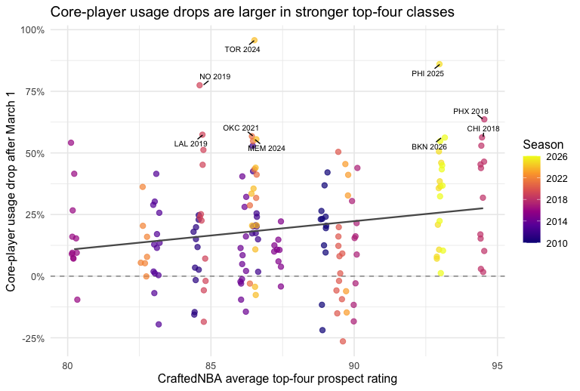
Figure 8. Top-four draft strength and core-player usage reduction among likely lottery candidates. Each point is one team-season. Core players are the top three pre-March starters, among players who stayed with the same team and appeared after March 1. The y-axis is the proportional drop in their combined minutes per team game after March 1.
Table 6. Exploratory model predicting late-season core-player usage reduction among likely lottery candidates.
Model | Term | Estimate | Std. error | p-value
Core-player usage drop rate | Top-four draft rating | 0.054 | 0.016 | 0.001
 | Pre-March core MPG | 0.000 | 0.001 | 0.591
 | 2012 season | 0.057 | 0.065 | 0.386
 | 2020 season | -0.178 | 0.063 | 0.005
 | 2021 season | 0.181 | 0.080 | 0.025
In Table 6, the key predictor is the standardized top4_avg_rating. The coefficient of 0.054 means that a one-standard-deviation stronger top-four draft class is associated with a 5.4 percentage point larger drop in late-season core-player usage, holding pre-March core-player minutes and disrupted-season controls fixed. The usual team-season p-value is 0.00098, and the season-clustered p-value is 0.0036. The clustered version is important because top4_avg_rating only changes by draft year, even though core_usage_drop_rate is measured for individual team-seasons. Overall, this suggests that stronger top-four draft classes are associated with larger late-season reductions in minutes for continuing core players, but the result should not be read as causal proof of tanking because injuries, rest, player development, and other availability issues can also affect minutes.
Because this core-usage result is stronger than the win-loss results, Table 7 checks whether it holds under related model specifications. The top-four draft rating remains positive when 2021 is excluded, while the position-adjusted lottery incentive is not a strong predictor of core_usage_drop_rate. This suggests that core-player minutes may respond more to the overall strength of the top of the draft than to the exact marginal lottery-odds gain from one March lottery position. The pre/post reform interaction is also not strong, so we do not find clear evidence that the 2019 lottery reform changed the core-usage relationship. The team-fit interaction is interesting but secondary, so we treat it as hypothesis-generating rather than as a main result.
Table 7. Sensitivity checks using core-player usage reduction as the outcome.
Model | Term | Estimate (pp) | p-value | Season-clustered p-value | N
Raw top-four rating | Top-four draft rating | 5.352 | 0.001 | 0.004 | 172
Pre/post interaction | Top-four rating | 4.284 | 0.030 | 0.156 | 172
 | Top-four rating x post-2019 | 0.808 | 0.809 | 0.811 | 172
Position-adjusted incentive | Position-adjusted incentive | 0.317 | 0.847 | 0.875 | 172
Position-adjusted, excluding 2021 | Position-adjusted incentive | 0.425 | 0.799 | 0.836 | 165
Raw top-four, excluding 2021 | Top-four draft rating | 5.438 | 0.001 | 0.004 | 165
Team-fit interaction | Top-four rating x team fit | 2.877 | 0.084 | 0.001 | 172
Top-35 rating | Top-35 draft rating | 3.162 | 0.074 | 0.191 | 172

Model Fit and Quality Checks
Table 8. Model fit statistics for the main formal models.
Model | Outcome | N | R-squared | Adjusted R-squared
Pre/post reform interaction | Tanking index | 175 | 0.146 | 0.110
Position-adjusted incentive |  | 175 | 0.140 | 0.114
Position-adjusted, excluding 2021 |  | 168 | 0.123 | 0.101
Team-fit interaction |  | 175 | 0.150 | 0.114
Raw top-four rating | Core-player usage drop rate | 172 | 0.121 | 0.094
Table 8 shows that all of the formal models explain a modest share of the variation in the outcomes. The tanking-index models have R-squared values between 0.123 and 0.15, with adjusted R-squared values near 0.11. The pre/post reform and team-fit versions do not improve fit much over the main position-adjusted model, so their value is mainly as robustness and heterogeneity checks. Excluding 2021 lowers the fit slightly, which supports treating that season as unusual but not as the only source of the pattern. The core-player usage model has a similar fit level, with an R-squared of 0.121 and an adjusted R-squared of 0.094, so its stronger interpretation comes more from the coefficient size and clustered p-value than from dramatically better overall fit.

Conclusions From the Formal Analysis
The formal analysis points in the expected direction, but the strength of the evidence depends on the outcome. In the main win-loss model, the position-adjusted draft incentive has a positive relationship with tanking_index, meaning teams with stronger lottery incentives tended to win fewer late-season games than expected. However, the estimate is noisy, so this supports a suggestive rather than causal conclusion.
The full tanking_index remains useful because it measures the size and direction of late-season underperformance instead of forcing teams into a yes/no tanking category. The team-fit extension is less conclusive: the interaction between top4_avg_rating and team_fit_score is not statistically significant, so our simple fit measure does not add clear evidence beyond overall draft strength.
The core-player usage model gives the clearest exploratory signal. Stronger top-four draft classes are associated with larger reductions in late-season minutes for continuing core players, and this pattern is stronger when using raw top-four draft strength than the position-adjusted lottery incentive. The 2021 season remains unusual, but excluding it does not reverse the main direction of the win-loss result.

VI. Next Steps
The results should be interpreted as evidence about tanking signals, not confirmed tanking. The project finds a positive relationship between top-four draft incentives and late-season underperformance, along with a stronger exploratory relationship between top-four draft strength and reduced core-player usage. Neither result proves that teams deliberately lost games, but both suggest that draft class quality belongs in discussions of tanking incentives.

Limitations and Cautions
The biggest limitation is that intent is not directly observable. Teams can lose late-season games or reduce core-player minutes for many reasons, including injuries, trades, rest, player development, and random performance. For that reason, the outcome variables in this report should be treated as proxies for tanking behavior rather than direct proof.
A second limitation is that draft strength mostly varies by season. The position-adjusted incentive adds team-level variation by combining draft quality with March lottery position, but the underlying draft-quality signal still comes from only 17 draft classes. The incentive measure is also simplified because it focuses on the marginal gain in top-four-pick probability from moving one lottery slot worse, rather than the exact value of each pick or team-specific player preferences.

Future Extensions
The most useful next step would be improving the core-player usage model with injury reports, transaction data, and inactive-list reasons. That would help separate strategic late-season roster management from ordinary player availability.
Another extension would improve team_fit_score. The current version uses broad position groups and pre-March box-score production, so a stronger version would include contract status, age, detailed roster needs, and team-specific draft evaluations.
A final extension would compare multiple draft-quality measures. CraftedNBA provides a consistent external rating, but future versions could test whether the results change using consensus mock drafts, top-prospect ratings, number of elite prospects, or later NBA outcomes such as win shares.

Final Takeaway
The most defensible conclusion is cautious: draft class quality appears relevant to tanking incentives, but the evidence is not strong enough to claim that stronger draft classes directly cause tanking. The project improves on simpler tanking analyses by combining playoff context, lottery position, standardized late-season underperformance, draft quality, and core-player usage into one framework.

References
- CraftedNBA. Draft Class Rankings.
- CraftedNBA. Best NBA Draft Prospects Since 2010.
- hoopR. SportsDataverse hoopR package.
- New York Post. (2026, February 12). Jazz, Pacers slammed with $600K in fines over tanking decisions.
- NBA.com. NBA Board of Governors approves changes to Draft Lottery system.
- NBA.com. NBA Draft Lottery explainer.
- NBA.com. Ties broken for order of selection in NBA Draft 2018.
- Price, J., Soebbing, B. P., Berri, D., & Humphreys, B. R. (2010). Tournament Incentives, League Policy, and NBA Team Performance Revisited.
- Taylor, B. A., & Trogdon, J. G. (2002). Losing to Win: Tournament Incentives in the National Basketball Association.

